West Seattle High School
Concert/Marching Band
Student Handbook
2018-19
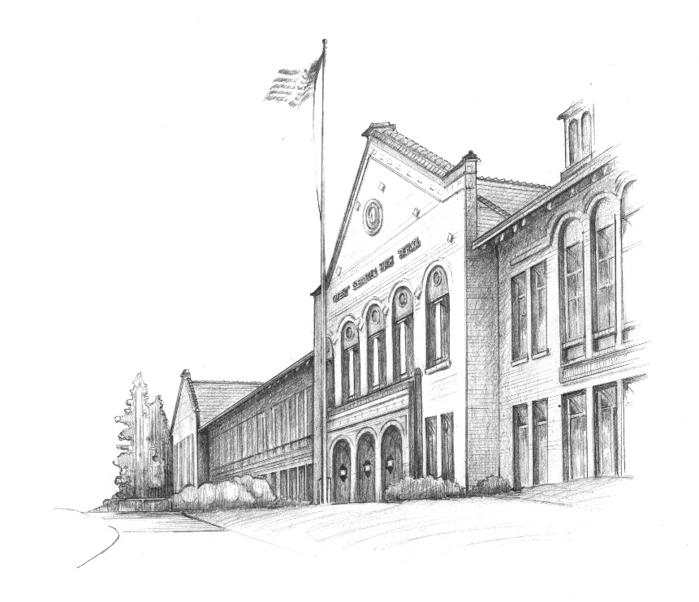
Pride*Leadership*Musicianship*Spirit*Dedication

Dear West Seattle Band Family,
Welcome back for another great year of WSHS music! I am truly excited to be back for my 7th year working with you. The goal this year is to build upon our successes of last few years as we continue our work to rebuild this program.
Last year we had a very successful year with participation in the Macy’s Holiday Parade, Junction Harvest Festival, Concert Band Festivals and our spring trip to Southern California. We continue to build a strong and vibrant music program at West Seattle HS but there is still a lot of work to be done. Our performances this year will include those that are the same as we have done in the past and a few new additions. This year we plan to participate in the Pacific Northwest Band Festival at the University of Washington in February and possibly another concert band festival in the spring. We will also be returning to Victoria BC for our Spring trip in May.
We will again be working hard to attract the attention of students at our “feeder” schools. The future or our program depends upon recruiting students into our program. We are planning on inviting students from Madison Middle School to join us for one of our home basketball games in the winter. I believe this connection is critical to our future success.
Last year we took a few giant steps toward the redevelopment of our music program but we still have lots of work to do. With your continued hard work and dedication we will achieve our goal of becoming one of the leading music programs in Seattle.

Sincerely,

Ethan Thomas
Director of Music
West Seattle High School

2018-19 Band Performance Calendar.
Sept. 8th – 9th – Band Camp at WSHS.
Friday, Sept. 14th – Football Game vs. Chief Sealth High School (Southwest Athletic Complex) 6:30pm
Friday, Sept. 21st – Football Game vs Nathan Hale HS Homecoming (Southwest Athletic Complex) 6:30pm
Friday, Sept. 22nd – Husky Band Day at the University of Washington Time TBD
Friday, Oct. 5th – Football Game vs. Ingraham HS (Southwest Athletic Complex) 6:30pm
Sunday, Oct. 28th – Junction Harvest Festival 11:00am
Friday, Nov. 23rd – Macy’s Holiday Parade
Friday, Dec. 7th – Basketball vs Lakeside – Varsity Girls and Boys (WSHS Gym – 6:30pm)
Friday, Dec. 14th – Basketball vs Bainbridge HS – Varsity Girls and Boys (WSHS Gym – 6:30pm)
Thursday, Dec. 20th – Winter Concert for Band/Orchestra (WSHS Theater) 7:00pm
Friday, Jan. 18th – Basketball vs Roosevelt HS – Varsity Girls and Boys (WSHS Gym – 6:30pm)
Saturday, Feb. 2nd – EBWME Solo and Ensemble Festival (SPU) (Students taking band for Occ. Ed. Credit must participate)
Saturday, March 16th – St. Patrick’s Day Parade
DATE TBD – EBMEA High School Concert Band Festival
May 18th – 20th – Victoria BC trip
Saturday, June 8th – Music in the Parks Competition at Wild Waves
Tuesday, June 11th – Spring Concert for Band/Orchestra (WSHS Theater) 7:00pm
Thursday, June 13th – Graduation (SWAC) Time TBA
Monday, June 17th – Music Department Banquet (WSHS Commons) 6:00pm

All performances and rehearsals are requirements of participation in band. Additional performances may be added throughout the year.

Band Leadership 2018-19

Below you will find the leadership structure of the 2018-19 school year. We are beginning to implement a more effective leadership program that will take several years to fully implement. In the Spring we will begin a new application process for students who are interested in becoming section leaders. The following is what we will be using this year:

Marching Band
Mr. Thomas

Drum Majors:
TBD

Section Leaders (As follows)
Flutes – Katy Jones and Chloe Rushing
Clarinets – Emma Laplante and Carli Evanson
Saxes – Lola Demurger and Caitlin Ward
Brass – Matthew Mote and Sarah Harker
Percussion – Nate Wuethrich and Adam Chin

Anticipated Costs
Below is a listing of the anticipated costs associated with the concert/marching band this year. PLEASE NOTE: The director and boosters are committed to working with families to ensure that all students interested in participating in the concert/marching band are able to do so regardless of the family’s ability to pay. If your family anticipates a difficulty in covering the expenses for your student, please request a financial aid application from Mr. Thomas by the end of September.
Band Expense Breakdown
Local Transportation $35
Music in the Parks – Wild Waves $50
Victoria Day Trip $340
Total with Both Trips $425
Total without Trips $35
Travel is NOT a requirement of participation in Band but is encouraged due to its musical and non-musical benefits for the students. While we encourage those families that can to make full payment for all expenses up front (this saves on staff time spent recording and processing payments) a payment plan has been set up for those families that are able to pay but need more time. The payment plan calls for a deposit of $65 followed by 6 monthly payments of $60. Students requesting financial aid should plan on participating in our fundraisers.
September 28th | $65
October 26th | $60
November 21st | $60
December 21st | $60
January 25th | $60
February 22nd | $60
March 29th | $60

All payments should be made using SchoolPay (accessed through your students account on the Source) or via check made out to WSHS Music and brought to the Fiscal Office (in the main office). You will be given a receipt for all transactions.

Uniform Information
Proper attire is required for participation in every performance. Students who are not dressed correctly may not be allowed to perform and their grade will be lowered as a result.
Concert Band: The attire for concert band will be all black.
- Black shirt or blouse (Dress shirt or polo – T-SHIRTS are NOT considered proper concert band attire)
- Black dress pants or skirts (Jeans and sweats are not considered concert band appropriate). Skirts or dresses should be an appropriate length at or below the knee.
- Black socks or stockings and black dress shoes (tennis shoes are NOT acceptable for concert wear).

Marching Band:
- WSHS Marching Band Uniforms. You will be fitted and assigned a uniform for your use this year. The uniform will be kept at the school and will be checked out for performances. Uniforms MUST be returned to the school immediately following the performance.
- Black tennis shoes and socks. These should be completely black and comfortable for marching. These can be purchased from any local retailer.
- NOTE – Long hair should be tied back with a hair colored tie.

Pep Band:
- Pep band t-shirt
- Blue Jeans
- Comfortable tennis shoes (No flip-flops or sandals)
- Band Hat

PLEASE NOTE: Families in need of financial assistance in order to secure uniform parts should see Mr. Thomas ASAP. The school has a selection of uniform parts that can be loaned out to students in need.
Course Outline
The WSHS band is the most visible performing ensemble on campus. We serve a variety of functions as the concert band, marching band and pep band for the school. We perform a diverse repertoire of music at school concerts, sporting events, parades, assemblies and other community events. As part of this class we will periodically travel to regional festivals and out of state competitions. Major areas of focus in this class will be developing strong musicianship, good rehearsal strategies and creating a healthy, positive community that fosters effective teamwork and leadership skills.
Required Materials:
- Instrument in good working condition.
- Music folder that includes this handbook and all music.
- Pencil and eraser.
- Necessary instrument related accessories:
  - Brass instruments – Valve oil, mouthpiece brush, soft cloth
  - Woodwinds – Supply of reeds, cleaning swab, cork grease.
  - Percussionists – Sticks/Mallets appropriate to your instrument(s).
Class Expectations:
- PLAN TO BE SUCCESSFUL! Set high expectations for yourself and work hard to achieve your goals.
- SUPPORT YOUR PEERS! We are all in this together. In order for us to perform at a high level we must all be in charge of boosting moral and building self-esteem.
- BE ON TIME! Classes are short and we have lots of hard work to do. Be in your seat with your instrument out and ready to play within 3 minutes of the bell.
- BE RESPONSIBLE! Be a team player and take care of business without complaints.
- BE RESPECTFUL! Build each other up. Don’t tear each other down.
Practice at home:
Success in any musical group does not happen without hard work in and out of class. It is important that you spend an adequate amount of time practicing your parts at home. Plan on practicing around 20-30 minutes every night. It is important to maintain consistency in your practicing rather than practicing for longer periods fewer times a week.
Performances:
Participation in performances is an expectation of being a part of this ensemble. The performance schedule of a high school band is very active and the presence and active participation of each band member is critical to the success of the performance. The band will be flexible with students participating in other school activities that occasionally conflict with the band, however, in these instances the following should be observed:
1. Two weeks written notice and a legitimate reason is required for a missed performance, with the exceptions being medical and family emergencies. Legitimate reasons include participation in another school sanctioned event or family religious engagements. 2. In the case of a medical or family emergency, information should be brought into the school when the student returns to class. 3. Students should communicate with athletic coaches or advisors about Wednesday band rehearsals, and when possible, make arrangements to be in attendance at the practice before a field show or parade performance. Each student plays a crucial role in the ensemble. Providing two weeks’ notice of a conflict allows us the opportunity to make adjustments so that the impact of a missing student is minimized.
Grading – Fall Semester

Grading Breakdown
Daily Performance/Participation 40%
Required Forms and Music Folder Checks 10%
Performances 25%
Playing Tests, Major/Minor Scales and written work 25%

Daily Performance Point Breakdown
Daily Performance points consist of actively participating and demonstrating good rehearsal habits.
Daily Point Breakdown (4 points possible per day) = 20 points per week
1 point – Attendance (Being on time, in seat, staying for the entire rehearsal)
2 points – Actively participating on your instrument and contributing to each class session
1 point – Contributing to a positive and constructive rehearsal atmosphere

Tests/Quizzes
Regular playing or written assessments will be required. These may include playing scales or excerpts from selections we are working on. Sometimes these tests are administered in class in front of peers. All students will be required to pass a test of major and minor scales.

ATTENDANCE:
Students are expected to be on time to class every day. Students arriving more than 10 minutes late without a note will be marked absent (in accordance with school policy). If a student has an unexcused absence they will NOT be able to make up the work for that day.
i.e. “It is the policy of the Seattle School Board that consistent attendance is essential to the Seattle Public Schools mission of academic achievement for every student in every school. Truant students miss critical instruction in key concepts, quickly fall behind in school, and are less likely to achieve academic success. Accordingly, school attendance is mandatory, and unexcused absences and truancy are prohibited within Seattle Public Schools.”

– Seattle Public Schools Policy No. 3121

Makeup/Late Work Policy:

Students with an excused absence are able to make up work within one week for full credit. Students who have unexcused absences may not make up work for those days. Late work will be accepted for 2 weeks after the due date for 80% of the credit. Get work in on time!
Academic Integrity:
Students will be held to the Academic Integrity Standards within West Seattle High School Student Handbook. In short, it is the responsibility of the student to display their own level of academic achievement. Students should always give cited credit to the work of other people, whether in group work or from copyrighted sources. Plagiarism, cheating, or any other form of academic dishonesty will have consequences as set forth in the Student Handbook. Consequences can include but are not limited to a zero grade for the assignment, parental notification, loss of course credit, detention, and/or short-term suspension.
How/When to Access Your Grade:
Your grade can be accessed either by seeing the teacher directly or by logging into the Source. Grades are updated by Friday of every week.
Teacher Support:
Students who need additional help can get extra help during lunch or after school.

1. Stay Positive. Negativity spreads. Those who don’t know may believe what they hear instead of what they see.
2. The band doesn’t change as much as you do. The most impressionable year is the first one.
3. The band is an emotional group; expect some ups and downs.
4. Everybody has feelings, even the staff. When the band is criticized, everyone feels it.
5. There is always room for improvement. Constructive suggestions should be welcomed, even if they hurt a little bit.
6. Anybody can be a critic—this takes no skill or background and bears no responsibility.
7. More drive and spirit in rehearsals means a better performance with fewer mistakes. Remember, you perform how you practice!
8. For the benefits received, expect some sacrifice. All for one, and one for all—or—know what is best for the band and just do it.
9. Be flexible. Adjust to the situation.
10. Dedication, Unity, and Intensity
11. Think and use your common sense when making decisions. When in doubt, ask someone in charge.
12. Put the good of the group above the desires of the individual.
13. Let all actions reflect positively on the band, the school, and the district.
14. To be early is to be on time, to be on time is to be late, and to be late is to be left.
15. Leave venues the way we found them.
16. Do everything with a Touch of Class

Parents Homework
Welcome to the WSHS music Community! We are a growing program with an enthusiastic group of students and parents. We had a wonderful year last year filled with many terrific events for the WSHS Band, Orchestra and Jazz Ensemble.
Below is a half sheet that I will need returned by Sept. 10th. Most of my communication home is through email. This will get you on the distribution list so that you are aware of what is going on this year.
I hope that you have had a chance to look at the band or orchestra handbook and made a note of the performance dates. If there are any schedule conflicts or if you have any concerns, please let me know soon. Please fill out the information below and return it to me by September 10th.
The West Seattle High School Music Department has a website (www.wshsmusic.org). If you would NOT like to have your students picture on the website (no names are attached to the pictures) please check the box below.
--------------------------------------------------------------------------------------------------------------------------Please detach this portion of the handbook and return to school by Sept. 15th.

__________________________ _____________________________
Student Name Parent Name

______________________ _________________________
Phone Number Email Address (please print clearly)

_____ Please DO NOT include my student’s picture on the music dept. website.

I HAVE READ THE SYLLABUS AND AGREE TO ABIDE BY THE POLICIES REGARDING:
Student
Initials
COURSE MATERIALS
ATTENDANCE
CLASSROOM EXPECTATIONS
ASSIGNMENTS/ASSESSMENTS
MAKEUP/LATE WORK
ACADEMIC INTEGRITY STATEMENT
GRADING POLICIES AND PROCEDURES
TEACHER SUPPORT

__________________________________________________
STUDENT’S PRINTED NAME

_____________________________________________________________________
STUDENT’S SIGNATURE DATE

__________________________________________________
PARENT’S PRINTED NAME

_____________________________________________________________________
PARENT’S SIGNATURE

